Objective

Describe the Development and Project Policies to construct and maintain the Help System and the training materials Project.

Scope

All process involved in the development or maintenance of the Help system.

References

HELP: (Innovasy Help Studio System):
http://www.innovasys.com/

Moodle
http://moodle.org/

Adobe
http://www.adobe.com/

DEV.IN.01 Versions and Builds
DEV.IN.02 Typographic convention
DEV.IN.03 Lessons learned
DEV.IN.04 Migrating to SCBD repository
DEV.IN.05 Applications passwords
DEV.REP.01 TOC Highlight plug-in
DEV.REP.02 HPS3 features
DEV.REP.03 HPS3 6 UN web text
DEV.REP.04 Training Material List
DEV.REP.05 Training Material State
DEV.PR.01 Importing documents into Help Studio.
DEV.PR.02 Team working with Help Studio though Visual Source safe.
DEV.PR.03 Working with Build Flags and Build Profiles.
DEV.PR.04 TOC Highlight plug-in
DEV.PR.05 PDF Generation.
DEV.PR.06 ISO Update
DEV.PR.07 Help system and training materials maintenance.
DEV.PR.08 Working with Multilingual Content in Help Studio.
DEV.FO.01 Release Check List.

Definitions

Online Help:
User assistance provided in a program or application that is typically accessed in a separate section of that application.

Procedure
is a specified series of actions, activities or operations which have to be executed in the same manner in order to always obtain the same result under the same circumstances (for example, emergency procedures).

Policy
Deliberate plan of action to guide actions to achieve a desired outcome.

Project management
Process of planning, organizing, and managing resources to bring about the successful completion of specific project goals and objectives.

Topic:
One Information Unit ( of The BCH Central Portal) that maybe a combination of text and graphics, clearly identified inside a BCH Project TRAINING Module, by its Module Number, Chapter, Section and Paragraph.

ContenT

Help system Management.

I) General Policies | The Project management must be done following the specified formal processes and standard best-practices for the maintenance of the on-line help system.  There are two categories: a) the operational (referred to the core activities) and b) support ones.  The key areas are:  - Project Management  - Document Management  - Training Materials  - Help System tool  - Team work  - Help System maintenance
II) Project management | a) Project Planning and management  This system has been planned to be developed in cycles. Formal definition of deliverables and deadlines allowed to achieve time and quality objectives. The different system versions and the deliverable’s date are specified in:  TM_BCH_Project Management.mpp

III) Document Management | a) Project document types  This project was designed with a strong focus on documentation, that is, creating formal documents that contain, as much as possible, the knowledge that was gathered during the construction of the Help System. The extensive documentation that was created guarantees the maintainability and quality of the project.  The standards and best practices are defined in four types of document. The goal is also to improve the coordination and communications between the persons involved in the project:
III) Document Management | Document |  |  |  | Name convention
III) Document Management | Process |  |  |  | DEV.PRO,number.name
III) Document Management | Instructional |  |  |  | DEV.IN. number.name
III) Document Management | Reports |  |  |  | DEV.REP.number.name
III) Document Management | Forms |  |  |  | DEV.FO.number.name
III) Document Management | Release Notes |  |  |  | BCH_Help_ReleaseNotes_date
III) Document Management | Note:  For each type of document it must be assigned a:  number : unique correlative number  Name : mnemonic short description.  Date: date in “yyyy-mmm-dd” format (e.g. 2010-jan-22)  b) Project documents maintenance.  Each time a project documents needs to be kept up-to-date, for many possible reasons, (i.e. enhancements, error corrections), It is necessary to keep track of these changes by associating a code number that identifies this new version in a unique form.  A detailed instructional is described in:  DEV.IN.01.Versions and Builds  c) Project documents templates.  Three document having a preset format, (template) were designed for the project documents:  i) TM_BCH_documents _Template. To describe project process.  ii) TM_BCH_Template. For training modules (i.e MO01 An introduction to CPB)  iii) TM_BCH_release_note (For the release notes which must accompany every release of the system)  d) Project documents typographic convention  A specific Typographic convention was implemented for the project documents. They are used to outline important information to the reader. The different pieces of information had a specific selection of typefaces, point size, line length, leading (line spacing) and letter spacing.  DEV.IN.02 Typographic convention
IV) Training Materials | a) Naming convention  Document code:  IDxxll  ID: document identification  xx: document number = 01,02 …  ll: language: En, Es, Fr, Ar, Ru, Zh  name
IV) Training Materials | ID |  | Name
IV) Training Materials | GD |  | Guidance document
IV) Training Materials | CC |  | Stakeholder curricula
IV) Training Materials | MO |  | Training Modules
IV) Training Materials | IM |  | Interactive Modules
IV) Training Materials | CS |  | Case Studies
IV) Training Materials | RR |  | Ready References
IV) Training Materials | DP |  | Discussion Points
IV) Training Materials | QZ |  | Quiz Questions
IV) Training Materials | OH |  | Operational Handbook
IV) Training Materials | PM |  | Promotional Materials
IV) Training Materials | AE |  | Exercises
IV) Training Materials | HM |  | Hermes development tool
IV) Training Materials | AX |  | Ajax development tool
IV) Training Materials | Examples:
IV) Training Materials | Document code |  |  | name
IV) Training Materials | CC01En |  |  | National Data Entry
IV) Training Materials | CC01Es |  |  | Ingreso de información Nacional
IV) Training Materials | b) Images in training modules  Document code:  MOxx_IIII_LNGS  xx: Module number = 01, 02, …  IIII: Image number = 0001, 0002, …  LNGS: Languages in which the image is valid (can be one or many). Examples: “en”, “es”, “en_es_fr”.  Examples: MO03_0056, MO04_0009  c) Images relating topic number to BCH Portal  Document code:  xxxxx  xxxxx: Topic number  Examples: 31000, 12140, …

b) Inventory
The complete inventory of training materials helps track the state of each training material, in English, Spanish, French, Arabic and Russian. For this inventory to remain a useful guide or resource, it must be kept strictly up-to-date. This can be found in:

DEV.REP.04 Training Material List.xls

c) State

There are four different states in which the training materials can be, according to the project life cycle. Each status has a specific color assigned.

 | State | Meaning
 |  | Updated
 |  | Updating in process
 |  | Expert review after translation
 |  | Requires revision
 |  | Doesn’t exist
The complete training materials status is described in:

DEV.REP.05 Training Material State.xls

d) Training Material maintenance

The following sequence of instructions is a simplification of the process which has been developed for the maintenance of the training materials. That process contains valuable knowledge that is the result of learning lessons, learning from errors and accumulating know-how and experience throughout the whole building of the Help System. It is meant to help simplify work and guarantee best quality of work.

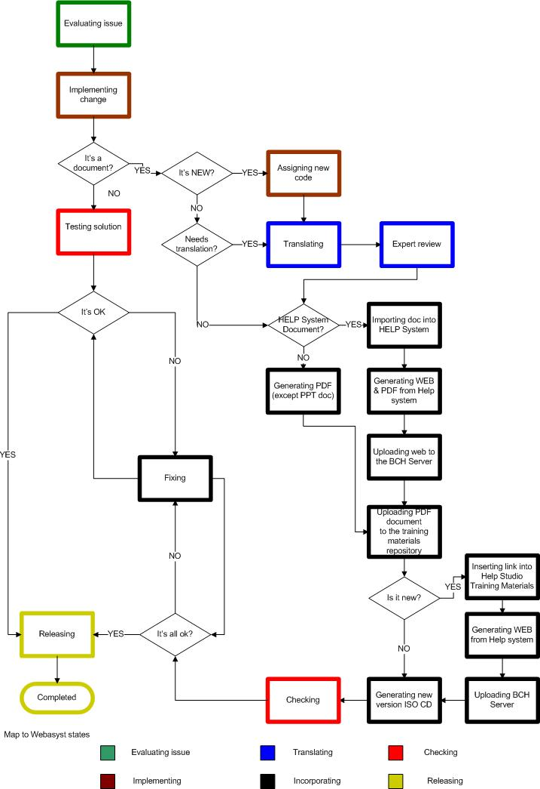

- Start ALWAYS by the English version (master language)
- If the document is new, assign a document filename, according to conventions, and update the list of materials document (DEV.REP.04 Training Material List); otherwise, use the code and name that was previously assigned.
- Use only document code conventions for file names, don’t change the document name
- Before doing any change, review ”DEV.REP.04 Training Material List” document, to analyze the impact that doing changes in one document will have on other documents. Make a list of all potentially impacted documents (separated by languages, for all languages)
- Once changes are done in the “source” document, add a revision note to the corresponding “DEV.REP.05 Training Material State” , briefly stating the changes that are in process or have been done.
- Document will not go public until synchronized in all languages.
- Repeat Step “e” for all impacted documents.
- Get the updated files for each language.
- Convert changed files to PDF (for each language, except for PPT documents) and update the public site.

The process itself is described in:

DEV.PR.07 Help system and training materials maintenance

V) Help System Tool | a) Import Word documents  In general, the sources of the Training Materials are Word documents.  This process describes how to import into Help System Studio the content of them, and how to create a help topic for each section of the document.  A detailed process is described in:  DEV.PR.01 Importing documents into Help Studio.  b) Working with Build Flags and Build Profiles.  Online help products generally have several different versions, and often some of these versions comprise only a subset of the help content of the project. For instance, when building a release, you might want to include only those topics which have been fully developed and tested in the release. However, when building for testing, you might need to build all topics, whatever their status. Hence, a straightforward mechanism to select which topics are to be built in a manner is required. Build flags and build profiles serve this purpose.  A detailed process is described in:  DEV.PR.03 Working with Build Flags and Build Profiles  c) PDF booklets  Help Studio can generate PDF booklets natively, from all topics that have already been created into the Help Studio. Adobe software or a PDF printer driver are not required.  Booklets enable to present the content in a format that is specially designed to be printed. You can re-use some or all of your existing Topics, or create new Topics specifically for booklets.  A detailed process is described in:  DEV.PR.05 PDF Generation  d) Multi Language Authoring:  HelpStudio allows you to work with any number of additional languages in addition to English (primary language of this project)  Details on how to define the project structure and Table of Contents and then localize for the additional languages, can be found in:  DEV.PR.08 Working with Multilingual Content in Help Studio.  e) Templates Customization  Help Studio allows to work with a page layout template that makes it easy to create a customized and adapt the layout without having to modify each topic individually.  In particular for these project it has been created the following templates:  - Help Studio 2005 Arabic Style  - Help Studio 2005  - ArabicPrint  f) TOC Highlighplug-in  A special plug-in was developed for this project, the aim is to Install a capability that extend the application (Innovasy Help Studio) in which the Online Help always highlights the current topic in the Table of Content TOC)  The problem description and the Solution implementation, is described in:  DEV.REP.01 TOC Highlight plug-in  The procedure:  DEV.PR.04 TOC Highlight plug-in  g) Help System features summary  A general tool overview and final user functionalities, are summarized in :  DEV.REP.02 HPS3 features
VI) Team work | a) Team work and collaboration  MS Visual SourceSafe (VSS), enables to control access to and store the history of the project. Users can collaborate in a team environment, working on different parts of the project at the same time. As VSS stores a full history of a project modification it allows to retrieve a previous version of a HelpStudio project in case an error occur.  A detailed instructional is described in:  DEV.PR.02 Team working with Help Studio though Visual Source safe.  The Software Configuration Management (SCM) used in this project was MS Visual SourceSafe (VSS), the SCBD’s tool is SVN, the structure and all documents were uploaded to SCBD’s repository.  A detailed process is described in:  DEV.IN.04 Migrating to SCBD repository  b) Team Lessons Learned  Lessons Learned are a principal component of an organizational culture committed to:  - Knowledge sharing  - Continuous improvement  It is a process to collect, register and share systematically all knowledge or understanding gained by experience in this project. (The experience may be positive, or negative). Therefore, promoting recurrence of successful outcomes and precluding the recurrence of unsuccessful.  These experiences must be registered in:  DEV.IN.03 Lessons learned
VII) Help System maintenance | a) Help System maintenance  Define mechanisms to assure the Help System and the training materials continues operating correctly, including changes, enhancements, errors correction and documentation kept up-to-date.  A detailed process is described in:  DEV.PR.07 Help system and training materials maintenance  b) Managing versions  To inform the Help system’s user about the recent changes, enhancements and bug fixes that was made to the product.  A released note must be written, in order to publicly inform what’s new.  A detailed instructional to assign the correct version identification is described in:  DEV.IN.01.Versions and Builds  c) Help system Backup  The project documents or product must be backup mainly for two purposes. The first is to restore a state following a disaster, and the second one, if they have been or corrupted or accidentally deleted.  BCH Online Help must be backup in:  SERVER: bch.cbd.int  USERNAME: UNEP-GEF  PASSWORD: dalyb-zoxex  The Backups URL’s must be stated in the release notes.  d) Compiled Web text  The compiled web text is a set of text phrases commonly used in the Help System. For this reason, it is convenient to have a repository, in all six UN languages, of these phrases. They can be found in:  DEV.REP.03 HPS3 6 UN web text  e) ISO training kit  An ISO image is an archive file (a.k.a. disk image) of an optical disc using a conventional ISO (International Standards Organization) format that is supported by many software vendors. ISO image files typically have a file extension of .ISO.  The process is stated in:  DEV.PR.06 ISO Update  f) Passwords  The complete list of the applications passwords, can be found in:  DEV.IN.05 Applications passwords

The DEV.FO.01 Release Check List document states everything that must accompany and everything that must be checked upon a release.

